**Emily_Cmajor Reference Review**

Note: The room tone shouldn’t be an issue but a more direct sound (no room tone) will be more representative of the signal that processing will be receiving. We’ll work with this for now. Also, I have a suspicion that it’s not room ambience but an actual feedback of the signal.

**Raw:** This is the audio as Emily sent it to me: <https://drive.google.com/open?id=0B9GwEdxq6mFxMmNhRkNtWlE1V2s>

**Raw Compressed:** This is the original audio with it’s dynamic range reduced

<https://drive.google.com/open?id=0B9GwEdxq6mFxUEwwNVBEOS1zcXc>

This is a view of the compressor working at 4:1, which means that every 4 db OVER the threshold 1 dB comes out. The red line is the amplitude reduction.

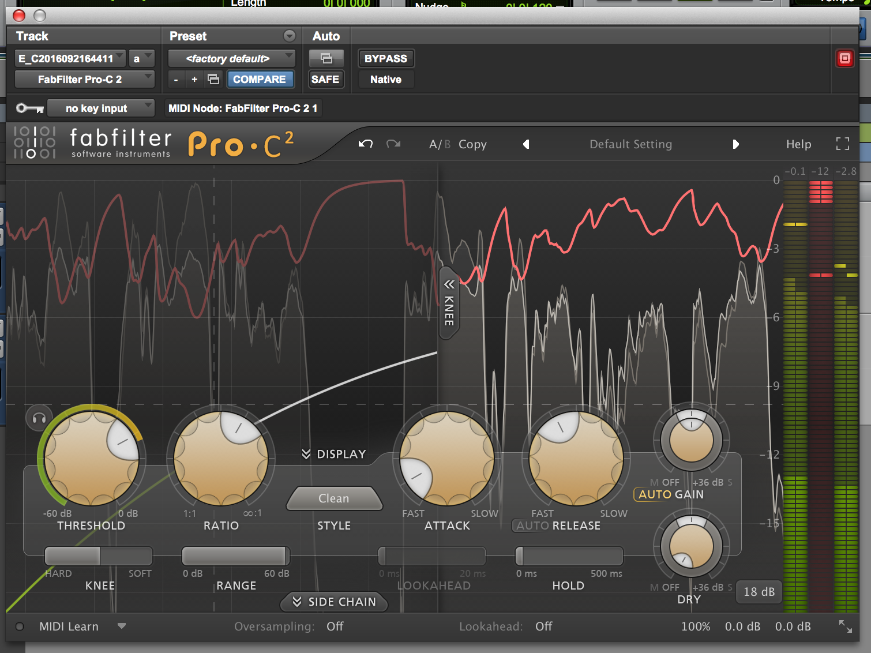

**Raw Filtered:** This is the original audio filtered. 192hz12dB/oct & 984hz12dB/oct. https://drive.google.com/open?id=0B9GwEdxq6mFxWW5oRzZPMFZvZzA

I’ve provided a visual of the scale sung towards the bottom of the octave and the top of the octave: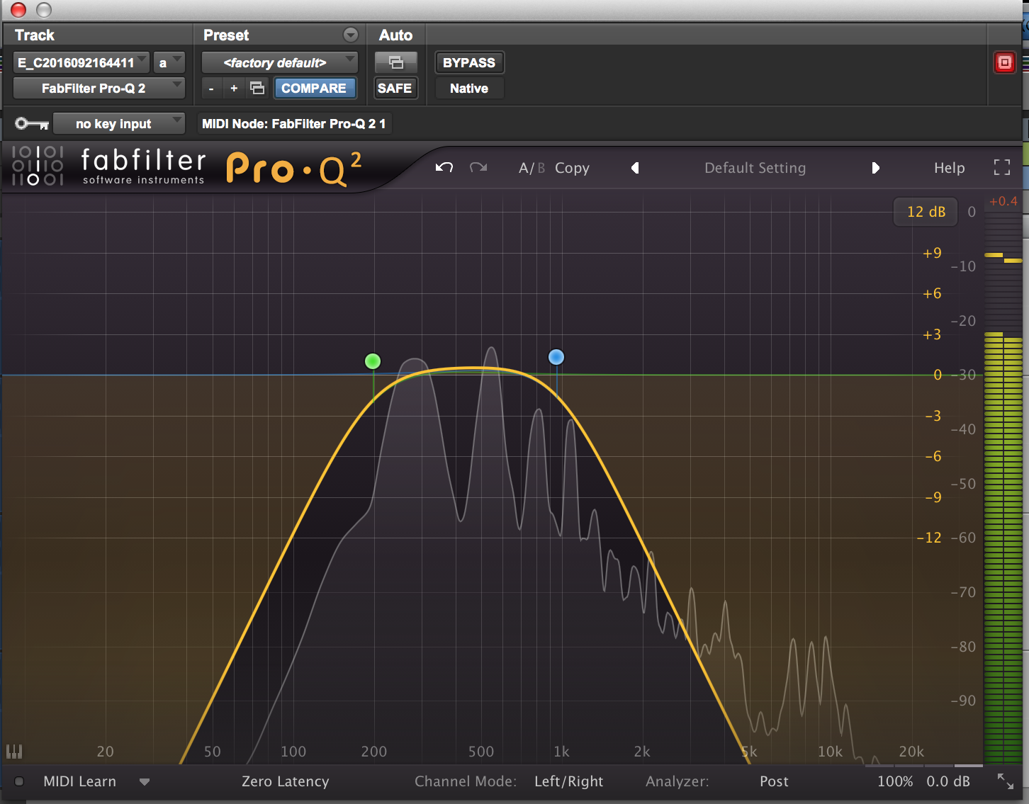

Here is a visual of the Raw pitches (untuned):

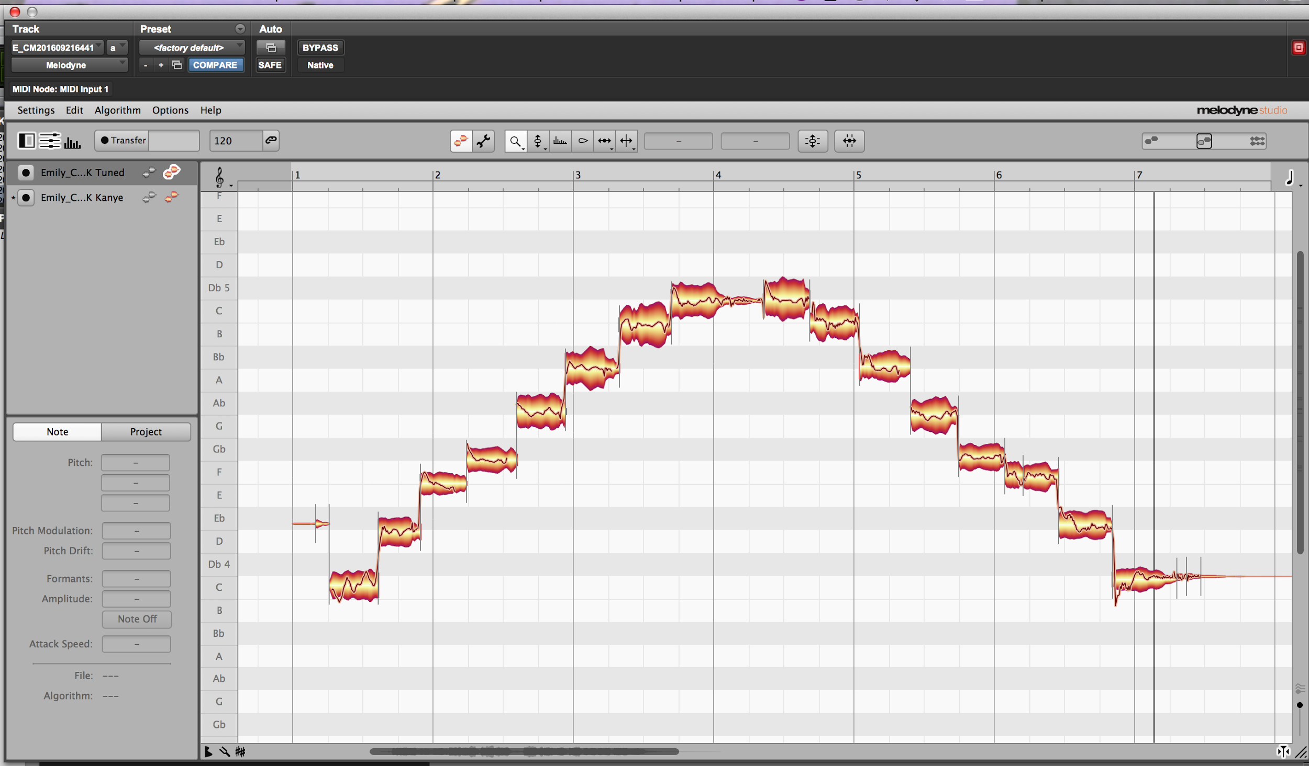

You can see that the scale begins in tune but drifts sharp.

**Tuned:** <https://drive.google.com/open?id=0B9GwEdxq6mFxNG1NaVk1VzNkc2c>

Here is the visual of the tuned pitches:

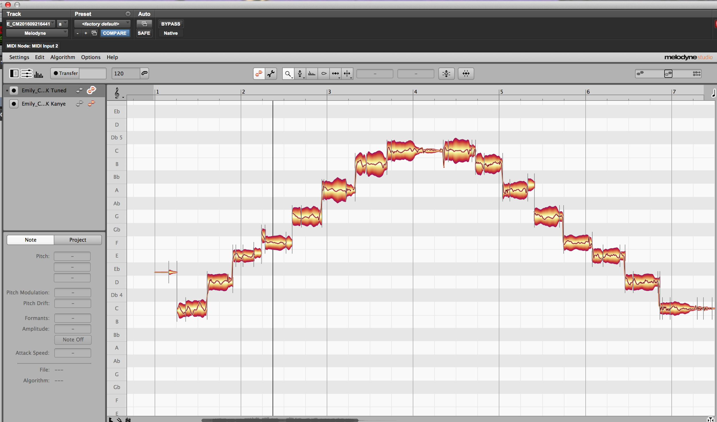

The goal is for the audio to retain some of the pitch characteristics with the intonation improved.

**Kanye**: This is the modern OVER-TUNED sound. The goal is to obliterate all the pitch nuances.

<https://drive.google.com/open?id=0B9GwEdxq6mFxYWtOd0QtYjdwQ2M>

Here is the visual:

